REQUIREMENTS SPECIFICATION DOCUMENT
Smart IoT Quality
Inspection System
Production Line Simulation

A real-time Industry 4.0 simulation for automated product inspection, virtual IoT sensor streaming, rule-based quality classification, live dashboard monitoring, alerts, and traceable production history.

Prepared by
Rotem Dino | 209168442 | Avigail Musai | 322227711
Chira Borochov | 345887046 | Jordan Daudu | 323909366
Binyamin Butolin | 315379362 | Ilan Markovich | 318502739
Elay Levi | 207365073

Document Roadmap
A polished overview of the system, requirements, quality attributes, and diagrams.
Updated scope: includes professional requirement metadata, testable acceptance criteria, implementation subtasks, role control, simulated scenarios, and API/message schema support.

26  FUNCTIONAL REQUIREMENTS  Sensors, backend, dashboard, alerts, admin, roles, reporting | 13  NON-FUNCTIONAL REQUIREMENTS  Performance, scalability, integrity, security, testability | 4  SYSTEM DIAGRAMS  Use case, block, communication, class diagrams

01  System Description  Overview, main entities, and high-level production flow. | 02  Functional Requirements  Complete user stories and acceptance criteria by module. | 03  Non-Functional Requirements  Quality attributes that define reliability and usability.
At a glance
The system simulates a smart manufacturing line in which virtual sensors generate inspection readings, transmit them via WebSockets, and allow a backend quality module to classify each product as PASS, WARNING, or FAIL.

Implementation focus
The design emphasizes asynchronous Python execution, real-time communication, persistent traceability, configurable thresholds, operator control, and monitoring through a live dashboard.

Table of Contents
Quick navigation map for the updated requirements, non-functional qualities, and UML design sections.

No. | Section | Main Content | Page
1. | System Description | Purpose, scope, entities, production flow, and quality status legend | 4
1.1 | Overview | Project context, IoT simulation scope, WebSocket flow, and quality logic | 4
1.2 | Main System Entities | Batch, Product, SensorReading, InspectionResult, Alert, SimulationRun, User, Role | 4
1.3 | High-Level System Flow | Sensor generation, ingestion, validation, storage, classification, dashboard, and alerts | 5
1.4 | Quality Status Legend | PASS, WARNING, and FAIL meaning | 5
2. | Functional Requirements | User stories, acceptance criteria, and implementation subtasks | 6
A | Virtual Sensor Simulation | FR-01 to FR-06: simulated sensors, identification, and readings | 6
B | Real-Time Communication and Data Ingestion | FR-07 to FR-09: WebSockets, validation, and storage | 12
C | Quality Inspection and Decision Logic | FR-10 to FR-11: classification and explainable decisions | 14
D | Dashboard and Monitoring | FR-12 to FR-14: live monitoring, details, filtering, and search | 17
E | Alerts and Notifications | FR-15 to FR-17: failed products, maintenance alerts, and sensor health | 19
F | Administration and Simulation Control | FR-18 to FR-20: thresholds, simulation control, and fault injection | 22
G | Reporting and Traceability | FR-21 to FR-22: historical reports and product traceability | 24
H | Roles, Scenarios, and Implementation Support | FR-23 to FR-26: roles, alert history, scenarios, and schemas | 26
2.8 | Functional Coverage Summary | Responsibility map by system area | 30
3. | Non-Functional Requirements | Performance, scalability, integrity, security, usability, logging, and testability | 31
3.1 | Non-Functional Implementation Subtasks | Implementation checklist for quality attributes | 32
4. | Diagrams | Visual architecture, communication flow, and class model reference | 35
4.1 | Use Case Diagram | Actors and major use cases | 36
4.2 | Block Diagram | System architecture and data flow | 37
4.3 | Communication Diagram | Runtime interaction and message flow | 39
4.4 | Class Diagram | Domain model and entity relationships | 40

1. System Description
Purpose, scope, main entities, and high-level operational flow.

1.1 Overview
The Smart IoT Quality Inspection System for a Production Line is an Industry 4.0 simulation project developed in Replit using virtual IoT sensors. The system simulates a smart manufacturing environment where products move through a production line and are inspected automatically using product-level readings and machine-level monitoring data.
Sensor data is transmitted in near real time to a backend server through WebSockets, enabling asynchronous communication, live dashboard updates, and measurable update targets. Python's asynchronous execution (asyncio) allows multiple virtual sensors to run concurrently without blocking the web server.
The system classifies product quality as PASS, WARNING, or FAIL using rule-based inspection logic with simulated AI-like elements where appropriate, such as visual defect categories and optional confidence scores. The design keeps advanced features practical for a course project while preserving traceability and fault detection.

1.2 Main System Entities
Entity | Description
Product | A manufactured item with a unique ID tracked through the production line.
Batch | A grouping of products used for production-run analysis.
SimulationRun | A controlled execution of the production-line simulation, including scenario, start time, state, and generated batches.
Sensor | A virtual IoT device such as Weight, Temperature, Vibration, Camera, Barcode, or Health sensor.
SensorReading | A time-stamped measurement containing value, unit, sensor ID, and product-level or machine-level context.
InspectionResult | The final quality classification decision, status, score/reason, and explanation.
Alert | Quality, maintenance, or sensor-health notification generated in near real time.
ThresholdConfiguration | Configurable limits for sensor values used by the quality engine.
User / Role | A project actor with permissions such as Quality Manager, Operator, Technician, or Administrator.

1.3 High-Level System Flow
1 | Virtual sensors generate readings as asynchronous background tasks.

2 | Data is streamed to the backend via WebSocket connections.

3 | The backend validates and stores readings in an optimized database structure.

4 | The Quality Module evaluates readings against active thresholds.

5 | Classifications (PASS / WARNING / FAIL) are pushed to the live dashboard.

6 | Alerts are triggered and displayed for abnormal production or sensor conditions.

1.4 Quality Status Legend
PASS  QUALITY STATUS  Product meets active inspection thresholds | WARNING  QUALITY STATUS  Product or machine behavior needs attention | FAIL  QUALITY STATUS  Product failed one or more inspection rules

2. Functional Requirements
User stories and acceptance criteria organized by system module.

A. Virtual Sensor Simulation
Requirement group overview
Defines the virtual IoT layer that produces product and machine readings without external hardware.

FR-01  TYPE  PRIORITY  SCOPE  USER STORY  ACCEPTANCE CRITERIA  SUBTASKS | Virtual Sensor Data Generation  Type: Functional  Priority: High  Scope: MVP  As a Virtual Sensor, I want to generate product-level and machine-level inspection readings automatically, so the system can simulate a realistic IoT production line without physical hardware.  • Given the simulation is running, each enabled virtual sensor emits readings at a configurable interval between 1 and 5 seconds.  • Each SensorReading includes sensorId, batchId, simulationRunId, value, unit, timestamp, and either productId or machineId according to the sensor type.  • Generated values include normal and abnormal ranges according to the active simulation scenario.  • Reading generation continues without manual input until the simulation is paused, stopped, or reset.  IMPLEMENTATION SUBTASKS TABLE  Task ID Implementation Subtask  FR-01.1 Define a shared SensorReading payload format with sensorId, productId/machineId, batchId, simulationRunId, value, unit, timestamp, and status source.  FR-01.2 Build asynchronous sensor loops that emit readings at configurable intervals without blocking the backend server.  FR-01.3 Create normal and abnormal random data ranges for realistic product-level and machine-level behavior.  FR-01.4 Add structured logging for generated packets to support debugging and test evidence.  FR-01.5 Test that enabled sensors continue emitting valid packets during a complete simulation run.

FR-02  TYPE  PRIORITY  SCOPE  USER STORY  ACCEPTANCE CRITERIA  SUBTASKS | Weight Inspection  Type: Functional  Priority: High  Scope: MVP  As a Virtual Weight Sensor, I want to send product-level weight readings, so the system can detect products outside the configured quality thresholds.  • Given a product has a valid Product ID, the weight sensor generates one weight reading for that product before final classification.  • Weight values are stored with a clear unit, such as grams, and linked to the Product, Batch, and SimulationRun records.  • The quality engine compares the value against configured warning and failure thresholds.  • Missing or non-numeric weight values are rejected by validation and do not affect the final decision.  IMPLEMENTATION SUBTASKS TABLE  Task ID Implementation Subtask  FR-02.1 Implement a WeightSensor module with configurable minimum, warning, and maximum limits.  FR-02.2 Generate a weight reading for every product only after Product ID creation is complete.  FR-02.3 Connect weight readings to ThresholdConfiguration rules used by the quality engine.  FR-02.4 Store each weight reading with Product, Batch, and SimulationRun references.  FR-02.5 Test normal, warning, fail, missing, and invalid weight values.

FR-03  TYPE  PRIORITY  SCOPE  USER STORY  ACCEPTANCE CRITERIA  SUBTASKS | Temperature Monitoring  Type: Functional  Priority: High  Scope: MVP  As a Virtual Temperature Sensor, I want to send machine-level temperature readings, so the system can detect overheating conditions that may affect production quality.  • Temperature readings represent the inspection station or machine environment, not the individual product weight/identity data.  • Given the simulation is running, temperature readings are streamed at least once every 5 seconds per enabled temperature sensor.  • Temperature spikes above the configured threshold create a WARNING or maintenance alert according to severity.  • Each reading includes an ISO-style timestamp and remains available for dashboard trend display.  IMPLEMENTATION SUBTASKS TABLE  Task ID Implementation Subtask  FR-03.1 Implement a TemperatureSensor async task that streams machine-level readings continuously.  FR-03.2 Add a temperature spike mode for fault-injection and edge-case testing.  FR-03.3 Persist timestamped temperature readings and sensor heartbeat information.  FR-03.4 Expose recent temperature values for dashboard history and trend display.  FR-03.5 Test that a configured temperature spike generates the expected maintenance alert.

FR-04  TYPE  PRIORITY  SCOPE  USER STORY  ACCEPTANCE CRITERIA  SUBTASKS | Vibration Monitoring  Type: Functional  Priority: High  Scope: MVP  As a Virtual Vibration Sensor, I want to transmit machine-level vibration data, so the system can identify abnormal machine behavior before it causes quality problems.  • Vibration readings represent machine behavior and are stored separately from product-level inspection data.  • The system detects both single extreme spikes and sustained abnormal vibration patterns.  • A maintenance alert is generated when vibration exceeds the configured severity rule.  • Recent vibration history is visible on the dashboard for investigation.  IMPLEMENTATION SUBTASKS TABLE  Task ID Implementation Subtask  FR-04.1 Implement a VibrationSensor generator with normal, spike, and sustained-abnormal vibration patterns.  FR-04.2 Create threshold/rule checks for extreme or sustained vibration values.  FR-04.3 Trigger a maintenance alert when abnormal vibration behavior is detected.  FR-04.4 Provide vibration history data for dashboard charts and investigation.  FR-04.5 Test both single-spike and sustained-vibration scenarios.

FR-05  TYPE  PRIORITY  SCOPE  USER STORY  ACCEPTANCE CRITERIA  SUBTASKS | Visual Defect Detection  Type: Functional  Priority: High  Scope: MVP  As a Virtual Camera Sensor, I want to report simulated visual inspection results, so the system can identify visible product defects in a practical course-level implementation.  • Visual inspection is simulated and does not require real image processing or physical camera hardware.  • For every inspected product, the camera sensor returns a defect category such as OK, scratch, crack, missing label, or unknown.  • The simulated result may include a confidence score from 0 to 100 to support AI-like scoring while remaining implementable.  • Visual defect status is linked to Product ID and influences the final PASS, WARNING, or FAIL decision.  IMPLEMENTATION SUBTASKS TABLE  Task ID Implementation Subtask  FR-05.1 Define simulated visual defect categories such as scratch, crack, missing label, unknown, or OK.  FR-05.2 Implement a CameraSensor result generator for every inspected product.  FR-05.3 Add an optional simulated confidence score and defect severity field.  FR-05.4 Link visual defect results to the correct Product ID and inspection decision.  FR-05.5 Test that critical visual defects create the expected FAIL classification.

FR-06  TYPE  PRIORITY  SCOPE  USER STORY  ACCEPTANCE CRITERIA  SUBTASKS | Product Identification  Type: Functional  Priority: High  Scope: MVP  As a Virtual Barcode Sensor, I want to assign unique product identifiers, so every reading and decision can be traced to the correct item and batch.  • Each product receives a unique Product ID before product-level sensors generate their readings.  • Product IDs are linked to Batch ID and SimulationRun ID using a consistent format, such as BATCH001-P0001.  • Duplicate Product IDs are rejected during an active simulation run.  • All product-level sensor packets include the correct Product ID and Batch ID.  IMPLEMENTATION SUBTASKS TABLE  Task ID Implementation Subtask  FR-06.1 Implement unique Product ID and Batch ID generation for each simulation run.  FR-06.2 Attach Product, Batch, and SimulationRun identifiers to every product-level sensor packet.  FR-06.3 Prevent duplicate product identifiers during active simulation.  FR-06.4 Create the product-to-batch linkage before sensor inspection begins.  FR-06.5 Test duplicate Product ID handling and product-to-batch mapping.

B. Real-Time Communication and Data Ingestion
Requirement group overview
Defines how readings move from sensors into the backend reliably and with validation.

FR-07  TYPE  PRIORITY  SCOPE  USER STORY  ACCEPTANCE CRITERIA  SUBTASKS | Real-Time Sensor Communication  Type: Functional  Priority: High  Scope: MVP  As a Virtual Sensor, I want to transmit data using WebSockets, so the system supports a real-time IoT data flow from sensors to backend and dashboard.  • Given a valid sensor packet is received by the backend, dashboard clients receive the update within 2 seconds under normal course-scale load.  • The system supports at least 5 concurrent virtual sensor streams without manual polling or page refresh.  • Dropped WebSocket connections are logged and either reconnected or marked unavailable within 10 seconds.  • Validated readings, alerts, and simulation events are broadcast only after backend validation succeeds.  IMPLEMENTATION SUBTASKS TABLE  Task ID Implementation Subtask  FR-07.1 Define a WebSocket message schema for sensor readings, alerts, simulation events, and acknowledgements.  FR-07.2 Support concurrent sensor connections to the backend server.  FR-07.3 Broadcast validated readings and status updates to connected dashboard clients.  FR-07.4 Add reconnect and error-handling behavior for dropped WebSocket connections.  FR-07.5 Test WebSocket behavior with multiple simultaneous virtual sensors.

FR-08  TYPE  PRIORITY  SCOPE  USER STORY  ACCEPTANCE CRITERIA  SUBTASKS | Sensor Data Validation  Type: Functional  Priority: High  Scope: MVP  As a Backend System, I want to validate incoming messages, so invalid data does not affect quality accuracy or crash the simulation.  • Given an incoming packet is missing required fields, the backend rejects it and records a validation error.  • Given a packet contains an invalid type, duplicated identifier, unsupported sensor type, or impossible timestamp, it is not stored or classified.  • Invalid packets are handled safely without stopping sensor simulation, dashboard updates, or active WebSocket sessions.  • The sender receives an acknowledgement or error response that identifies the validation failure.  IMPLEMENTATION SUBTASKS TABLE  Task ID Implementation Subtask  FR-08.1 Create a validation layer for required fields, data types, ranges, timestamps, and allowed sensor types.  FR-08.2 Reject malformed, incomplete, duplicated, or corrupted packets safely.  FR-08.3 Log validation failures with enough detail for later debugging.  FR-08.4 Return acknowledgement or error responses to the relevant sensor/client.  FR-08.5 Test missing fields, invalid types, duplicate packets, and bad timestamps.

FR-09  TYPE  PRIORITY  SCOPE  USER STORY  ACCEPTANCE CRITERIA  SUBTASKS | Time-Stamped Sensor Storage  Type: Functional  Priority: High  Scope: MVP  As a Backend System, I want to store validated readings with timestamps, so product history, machine history, and quality trends can be analyzed later.  • Only validated packets are persisted as SensorReading records.  • Each reading is stored with timestamp, sensorId, productId or machineId, batchId, and simulationRunId where relevant.  • Database indexes support lookup by timestamp, sensorId, productId, batchId, and simulationRunId.  • Historical records remain available after stop/pause; reset clears active dashboard state but does not delete saved history unless a demo cleanup option is selected.  IMPLEMENTATION SUBTASKS TABLE  Task ID Implementation Subtask  FR-09.1 Design persistence models for Sensor, Product, Batch, SimulationRun, SensorReading, and InspectionResult.  FR-09.2 Add indexes for timestamp, sensorId, productId, batchId, and simulationRunId queries.  FR-09.3 Save only validated readings through a clear repository/data-access layer.  FR-09.4 Create query functions for history screens, product details, and reports.  FR-09.5 Test persistence behavior after stop, pause, reset, and backend restart where supported by Replit.

C. Quality Inspection and Decision Logic
Requirement group overview
Defines the core rules engine that converts raw readings into explainable quality outcomes.

FR-10  TYPE  PRIORITY  SCOPE  USER STORY  ACCEPTANCE CRITERIA  SUBTASKS | Product Quality Classification  Type: Functional  Priority: High  Scope: MVP  As a Quality Inspection Module, I want to analyze all relevant product-level readings and related machine conditions, so products can be classified as PASS, WARNING, or FAIL.  • Given all required product-level readings are available, the module produces exactly one final InspectionResult per product.  • Values outside hard failure limits or critical visual defects result in FAIL; values near limits or affected by machine warnings result in WARNING.  • Products within active thresholds and without simulated defects are classified as PASS.  • The final decision is saved in the database and published to the dashboard within 2 seconds after classification.  IMPLEMENTATION SUBTASKS TABLE  Task ID Implementation Subtask  FR-10.1 Implement a rule-based quality inspection engine.  FR-10.2 Aggregate all relevant sensor readings for each product before final decision.  FR-10.3 Calculate PASS, WARNING, or FAIL according to active thresholds and defect rules.  FR-10.4 Persist the final inspection result and publish it to dashboard/reporting flows.  FR-10.5 Test PASS, WARNING, and FAIL classification cases with known input readings.

FR-11  TYPE  PRIORITY  SCOPE  USER STORY  ACCEPTANCE CRITERIA  SUBTASKS | Inspection Decision Explanation  Type: Functional  Priority: High  Scope: MVP  As a Quality Inspection Module, I want to provide clear explanations, so users understand why each product received its quality status.  • Every InspectionResult includes a human-readable explanation, including PASS decisions where the product is within limits.  • WARNING and FAIL explanations identify the sensor, rule, threshold, actual value, and defect category when relevant.  • Explanations are stored with the InspectionResult and shown in live dashboard and product details views.  • If multiple rules are triggered, the explanation lists the most severe reason first.  IMPLEMENTATION SUBTASKS TABLE  Task ID Implementation Subtask  FR-11.1 Capture the specific rule, sensor, threshold, actual value, and severity behind each decision.  FR-11.2 Generate clear human-readable explanations for PASS, WARNING, and FAIL outcomes.  FR-11.3 Store the explanation together with the InspectionResult record.  FR-11.4 Show the explanation in the live dashboard and product details screen.  FR-11.5 Test multi-rule explanations and severity ordering.

D. Dashboard and Monitoring
Requirement group overview
Defines how managers and operators observe real-time and historical production states.

FR-12  TYPE  PRIORITY  SCOPE  USER STORY  ACCEPTANCE CRITERIA  SUBTASKS | Live Dashboard Monitoring  Type: Functional  Priority: High  Scope: MVP  As a Quality Manager, I want to monitor the production line through a live dashboard, so I can see product quality, machine behavior, and alerts in near real time.  • Dashboard updates appear within 2 seconds after the backend receives a valid sensor packet or inspection result.  • The dashboard displays PASS, WARNING, and FAIL counters, latest inspected products, active alerts, and sensor online/offline status.  • Dashboard data updates through WebSockets without requiring manual browser refresh.  • Simulation state changes such as start, pause, stop, and reset are reflected consistently on connected dashboard clients.  IMPLEMENTATION SUBTASKS TABLE  Task ID Implementation Subtask  FR-12.1 Build dashboard sections for KPIs, latest products, active alerts, sensor status, and simulation state.  FR-12.2 Subscribe the frontend to WebSocket updates from the backend.  FR-12.3 Render PASS, WARNING, and FAIL counters in real time.  FR-12.4 Synchronize dashboard state with simulation start, pause, stop, and reset actions.  FR-12.5 Test dashboard update delay from sensor packet to visible UI update.

FR-13  TYPE  PRIORITY  SCOPE  USER STORY  ACCEPTANCE CRITERIA  SUBTASKS | Product Inspection Details  Type: Functional  Priority: High  Scope: MVP  As a Quality Manager, I want to view detailed information for a selected product, so I can investigate specific inspection outcomes and verify traceability.  • Given a valid Product ID is searched, the screen shows the product, batch, simulation run, readings, final result, explanation, and related alerts.  • Associated sensor readings are displayed in chronological order with value, unit, timestamp, and sensor source.  • Product-level data is clearly separated from related machine-level context when shown together.  • Invalid or missing Product IDs produce a clear message without application failure.  IMPLEMENTATION SUBTASKS TABLE  Task ID Implementation Subtask  FR-13.1 Create a Product ID search input and matching backend endpoint.  FR-13.2 Fetch product, batch, simulation run, readings, inspection result, and related alerts in one view.  FR-13.3 Display a chronological reading timeline for the selected product.  FR-13.4 Handle missing or invalid Product IDs with a clear user message.  FR-13.5 Test product detail lookup for PASS, WARNING, FAIL, and missing-product cases.

FR-14  TYPE  PRIORITY  SCOPE  USER STORY  ACCEPTANCE CRITERIA  SUBTASKS | Filtering and Search  Type: Functional  Priority: Medium  Scope: MVP  As a Quality Manager, I want to filter inspection results, so I can investigate quality issues efficiently across products, batches, sensors, and simulation runs.  • Users can filter by Product ID, Batch ID, SimulationRun ID, status, sensor type, and time range.  • Combined filters return matching records without requiring a full page reload.  • Course-scale result lists update within 3 seconds for normal demo data volumes.  • A reset action clears all filters and restores the default latest-results view.  IMPLEMENTATION SUBTASKS TABLE  Task ID Implementation Subtask  FR-14.1 Implement filters for Product ID, Batch ID, SimulationRun ID, status, sensor type, and time range.  FR-14.2 Add backend query parameters that support combined filters.  FR-14.3 Refresh the result list dynamically without manual page reload.  FR-14.4 Provide a reset/clear-filters action for fast navigation.  FR-14.5 Test combined filter behavior and empty-result messages.

E. Alerts and Notifications
Requirement group overview
Defines immediate visibility into failed products, maintenance conditions, and sensor availability.

FR-15  TYPE  PRIORITY  SCOPE  USER STORY  ACCEPTANCE CRITERIA  SUBTASKS | Failed Product Alerts  Type: Functional  Priority: High  Scope: MVP  As a Production Line Operator, I want to receive alerts for failed products, so defective items can be identified immediately during the simulated production flow.  • When a product receives a FAIL classification, a failed-product alert is created and pushed to the dashboard within 2 seconds.  • The alert includes Product ID, Batch ID, SimulationRun ID, failure reason, sensor source, severity, and timestamp.  • Failed-product alerts remain available in historical alert records after the simulation stops.  • Duplicate alerts for the same final FAIL result are not created.  IMPLEMENTATION SUBTASKS TABLE  Task ID Implementation Subtask  FR-15.1 Create an alert whenever a product receives a FAIL classification.  FR-15.2 Include Product ID, Batch ID, SimulationRun ID, failure reason, sensor source, severity, and timestamp in the alert payload.  FR-15.3 Push failed-product alerts to the dashboard through WebSockets.  FR-15.4 Persist failed-product alerts for historical review and traceability.  FR-15.5 Test failed product alerts in both live dashboard and historical alert views.

FR-16  TYPE  PRIORITY  SCOPE  USER STORY  ACCEPTANCE CRITERIA  SUBTASKS | Maintenance Alerts  Type: Functional  Priority: High  Scope: MVP  As a Maintenance Technician, I want to receive machine behavior alerts, so temperature or vibration problems can be handled before they affect more products.  • Maintenance alerts are triggered by configured temperature spikes, vibration spikes, sustained abnormal vibration, or sensor health events.  • Each alert identifies the sensor, station/machine context, severity, timestamp, and triggering value.  • Alerts remain Active until acknowledged or resolved according to the alert workflow.  • The dashboard distinguishes maintenance alerts from product-failure alerts.  IMPLEMENTATION SUBTASKS TABLE  Task ID Implementation Subtask  FR-16.1 Define maintenance rules for temperature spikes, vibration spikes, sustained vibration, and unstable machine behavior.  FR-16.2 Detect the specific sensor or machine context that caused the maintenance condition.  FR-16.3 Generate maintenance alert records with severity and timestamp.  FR-16.4 Add acknowledge/clear behavior for alerts that remain active until handled.  FR-16.5 Test temperature and vibration maintenance alert scenarios.

FR-17  TYPE  PRIORITY  SCOPE  USER STORY  ACCEPTANCE CRITERIA  SUBTASKS | Sensor Health Monitoring  Type: Functional  Priority: High  Scope: MVP  As a Maintenance Technician, I want to monitor virtual sensor health, so disconnected or silent sensors are identified quickly.  • Each enabled virtual sensor sends a heartbeat or status message at least every 5 seconds while the simulation is running.  • A sensor is marked Offline after 10 seconds without heartbeat or after a disconnected WebSocket state is confirmed.  • Offline status is displayed on the dashboard and creates a sensor-health alert.  • When the sensor resumes heartbeat, its status returns to Online and the recovery event is logged.  IMPLEMENTATION SUBTASKS TABLE  Task ID Implementation Subtask  FR-17.1 Emit heartbeat or status messages from each virtual sensor.  FR-17.2 Track the last-seen timestamp for every sensor instance.  FR-17.3 Mark sensors offline after missed heartbeats or disconnected streams.  FR-17.4 Display online/offline sensor state and related alerts on the dashboard.  FR-17.5 Test offline detection after 10 seconds without heartbeat and recovery after heartbeat resumes.

F. Administration and Simulation Control
Requirement group overview
Defines configuration, simulation operation, and controlled fault testing for the system.

FR-18  TYPE  PRIORITY  SCOPE  USER STORY  ACCEPTANCE CRITERIA  SUBTASKS | Threshold Configuration  Type: Functional  Priority: Medium  Scope: MVP  As a System Administrator, I want to configure quality thresholds, so inspection rules can be adjusted without changing source code.  • Only an administrator role can edit threshold values in the configuration UI.  • Threshold input is validated before saving, including min/max order and numeric range checks.  • Saved thresholds persist in the database and apply to new inspection decisions without restarting the system.  • Threshold changes are logged with timestamp, role, and affected sensor type.  IMPLEMENTATION SUBTASKS TABLE  Task ID Implementation Subtask  FR-18.1 Create a threshold configuration model/table for each sensor type.  FR-18.2 Build an administrator UI for editing min, warning, and max threshold values.  FR-18.3 Validate threshold input before saving changes to the database.  FR-18.4 Reload active thresholds without restarting the backend or simulation.  FR-18.5 Test invalid threshold configuration, including min greater than max and non-numeric input.

FR-19  TYPE  PRIORITY  SCOPE  USER STORY  ACCEPTANCE CRITERIA  SUBTASKS | Simulation Control  Type: Functional  Priority: High  Scope: MVP  As a Production Line Operator, I want to start, pause, stop, and reset the simulation, so the production-line demo remains controlled and repeatable.  • The operator can perform global start, pause, stop, and reset actions from the dashboard.  • Simulation state is synchronized across sensors, backend, and connected dashboard clients within 2 seconds.  • Reset clears active runtime buffers and dashboard state; persisted historical records remain unless a specific demo cleanup action is selected.  • Invalid state transitions are disabled, such as starting an already running simulation.  IMPLEMENTATION SUBTASKS TABLE  Task ID Implementation Subtask  FR-19.1 Implement start, pause, stop, and reset commands in the simulation controller.  FR-19.2 Synchronize simulation state across sensors, backend, and dashboard clients.  FR-19.3 Clear runtime data on reset according to the defined reset rules.  FR-19.4 Disable invalid UI actions based on the current simulation state.  FR-19.5 Test start, pause, stop, reset, and invalid transition states.

FR-20  TYPE  PRIORITY  SCOPE  USER STORY  ACCEPTANCE CRITERIA  SUBTASKS | Fault Injection Simulation  Type: Functional  Priority: Medium  Scope: Extended  As a System Administrator, I want to inject simulated faults, so edge cases and alert behavior can be demonstrated safely.  • The administrator can trigger predefined faults such as overweight product, camera defect, temperature spike, vibration spike, and sensor disconnection.  • Injected faults can be associated with a selected sensor, product, batch, or simulation scenario when relevant.  • The expected classification or alert is generated and logged after the fault is injected.  • Fault injection is clearly marked as simulated test data and does not require physical hardware.  IMPLEMENTATION SUBTASKS TABLE  Task ID Implementation Subtask  FR-20.1 Add administrator controls for spike, disconnection, overweight, and visual-defect fault scenarios.  FR-20.2 Route injected faults to a selected sensor, product, batch, or simulation run.  FR-20.3 Verify that the expected alert and classification are generated after injection.  FR-20.4 Log each injected fault event for testing and audit purposes.  FR-20.5 Test each fault injection scenario and expected result.

G. Reporting and Traceability
Requirement group overview
Defines historical analysis and end-to-end evidence for every quality decision.

FR-21  TYPE  PRIORITY  SCOPE  USER STORY  ACCEPTANCE CRITERIA  SUBTASKS | Historical Quality Reports  Type: Functional  Priority: Medium  Scope: Extended  As a Quality Manager, I want to view historical quality reports, so production trends and repeated defects can be analyzed after simulation runs.  • Reports show PASS, WARNING, and FAIL statistics over time, by batch, and by simulation run.  • Users can filter reports by date range, batch, status, sensor type, and scenario.  • Reports use persisted data and remain available after the simulation stops or pauses.  • For normal course-scale data, report summaries load within 5 seconds.  IMPLEMENTATION SUBTASKS TABLE  Task ID Implementation Subtask  FR-21.1 Aggregate PASS, WARNING, and FAIL statistics by time period, production batch, and simulation run.  FR-21.2 Build a reporting endpoint and matching dashboard/report screen.  FR-21.3 Add filters for date range, batch, status, sensor type, and scenario.  FR-21.4 Display summary statistics and trends after each simulation run.  FR-21.5 Test report filters and PASS/WARNING/FAIL aggregation accuracy.

FR-22  TYPE  PRIORITY  SCOPE  USER STORY  ACCEPTANCE CRITERIA  SUBTASKS | Product Traceability  Type: Functional  Priority: High  Scope: MVP  As a Quality Manager, I want inspection decisions to be traceable, so each quality outcome can be verified from source readings and rules.  • Each InspectionResult links back to the product-level readings and related machine context that influenced the decision.  • The database preserves the SimulationRun-to-Batch-to-Product-to-Reading-to-Result hierarchy.  • Users can drill down from report summary to product details and then to source readings.  • Traceability data remains available after the simulation finishes and after dashboard reset.  IMPLEMENTATION SUBTASKS TABLE  Task ID Implementation Subtask  FR-22.1 Maintain links from InspectionResult to the readings and machine context that influenced the decision.  FR-22.2 Preserve the SimulationRun-to-Batch-to-Product-to-Reading hierarchy in the database.  FR-22.3 Add drill-down navigation from reports to product details and source readings.  FR-22.4 Keep audit/traceability data available after the simulation finishes.  FR-22.5 Test traceability navigation from report to product details and source readings.

H. Roles, Scenarios, and Implementation Support
Requirement group overview
Defines role permissions, alert lifecycle history, scenario-based simulation behavior, and implementation-facing message schema documentation.
FR-23  TYPE  PRIORITY  SCOPE  USER STORY  ACCEPTANCE CRITERIA  SUBTASKS | User Roles and Access Control  Type: Functional  Priority: Medium  Scope: Extended  As a System Administrator, I want role-based access control, so sensitive actions are limited to the correct project actors.  • The system supports at least four roles: Quality Manager, Production Line Operator, Maintenance Technician, and System Administrator.  • Quality Managers can view dashboards, product details, traceability, and reports.  • Production Line Operators can control simulation state, while Maintenance Technicians can acknowledge maintenance alerts.  • Only System Administrators can edit thresholds, inject faults, configure scenarios, and manage role settings.  IMPLEMENTATION SUBTASKS TABLE  Task ID Implementation Subtask  FR-23.1 Define a simple User and Role model suitable for a Replit course project.  FR-23.2 Map dashboard actions to allowed roles and disable unavailable actions in the UI.  FR-23.3 Add backend checks for threshold editing, fault injection, scenario configuration, and reset cleanup.  FR-23.4 Display the active role in the dashboard for demo clarity.  FR-23.5 Test that unauthorized roles cannot perform restricted actions.
FR-24  TYPE  PRIORITY  SCOPE  USER STORY  ACCEPTANCE CRITERIA  SUBTASKS | Alert Acknowledgement History  Type: Functional  Priority: Medium  Scope: Extended  As a Maintenance Technician, I want acknowledged alerts to be saved with status history, so maintenance handling can be reviewed later.  • Alerts support clear lifecycle states: Active, Acknowledged, Resolved, and optionally Cleared for demo reset.  • Acknowledgement stores alertId, actor/role, timestamp, and optional note where implemented.  • Acknowledged and resolved alerts remain available in alert history and reports.  • The live dashboard clearly separates active alerts from historical acknowledged alerts.  IMPLEMENTATION SUBTASKS TABLE  Task ID Implementation Subtask  FR-24.1 Extend the Alert model with status, acknowledgedBy, acknowledgedAt, resolvedAt, and optional note fields.  FR-24.2 Add dashboard actions for acknowledging and resolving alerts according to role permission.  FR-24.3 Persist alert status changes as part of the audit trail.  FR-24.4 Add filters for active, acknowledged, and resolved alert history.  FR-24.5 Test alert acknowledgement and resolution flow from live dashboard to history.
FR-25  TYPE  PRIORITY  SCOPE  USER STORY  ACCEPTANCE CRITERIA  SUBTASKS | Simulation Scenario Configuration  Type: Functional  Priority: Medium  Scope: Extended  As a System Administrator, I want to select predefined simulation scenarios, so normal and abnormal production behavior can be demonstrated consistently.  • Scenario options include Normal Run, High Defect Rate, Sensor Disconnect, Temperature Spike, Vibration Fault, and Mixed Fault Demo.  • The selected scenario affects virtual sensor behavior using configured probabilities and fault rules.  • Scenario name and configuration are stored with the SimulationRun for reporting and traceability.  • Scenario selection can be changed before a new run or during a controlled demo according to system rules.  IMPLEMENTATION SUBTASKS TABLE  Task ID Implementation Subtask  FR-25.1 Create predefined scenario profiles for normal operation and major fault demonstrations.  FR-25.2 Connect scenario selection to sensor simulators and fault injection logic.  FR-25.3 Store selected scenario metadata with the SimulationRun record.  FR-25.4 Show the active scenario on the dashboard and reports.  FR-25.5 Test each scenario and confirm expected readings, classifications, and alerts.
FR-26  TYPE  PRIORITY  SCOPE  USER STORY  ACCEPTANCE CRITERIA  SUBTASKS | API and Message Schema Documentation  Type: Functional  Priority: Medium  Scope: MVP  As a Dev Team, we want documented API and WebSocket message schemas, so all simulated IoT components communicate consistently during implementation.  • The project documents SensorReading, InspectionResult, Alert, Heartbeat, SimulationEvent, and ThresholdConfiguration message formats.  • Each schema includes required fields, optional fields, example valid messages, and example invalid messages.  • REST endpoints and WebSocket event names are documented in the same naming style used by the implementation.  • Schema changes are versioned or clearly noted so diagrams, code, and requirements remain aligned.  IMPLEMENTATION SUBTASKS TABLE  Task ID Implementation Subtask  FR-26.1 Document WebSocket schemas for sensor readings, heartbeats, alerts, and simulation events.  FR-26.2 Document REST/API endpoints for dashboard queries, reports, thresholds, and product details.  FR-26.3 Add valid and invalid example payloads for validation and testing.  FR-26.4 Keep schema names aligned with the class diagram and communication diagram.  FR-26.5 Review schemas before implementation to avoid inconsistent field names across components.

2.8 Functional Coverage Summary
Area | Requirement IDs | Primary Responsibility
Virtual Sensors | FR-01 - FR-06 | Generate realistic product-level and machine-level sensor data
Backend Ingestion | FR-07 - FR-09 | Validate, stream, and persist real-time readings
Quality Logic | FR-10 - FR-11 | Classify products and explain decisions
Dashboard | FR-12 - FR-14 | Monitor, investigate, filter, and search inspection data
Alerts | FR-15 - FR-17, FR-24 | Notify failed products, maintenance issues, sensor health changes, and acknowledgement history
Admin & Simulation | FR-18 - FR-20, FR-25 | Configure thresholds, control simulations, inject faults, and manage demo scenarios
Reporting & Traceability | FR-21 - FR-22 | Analyze quality history and preserve decision evidence
Roles & Integration Support | FR-23, FR-26 | Control role-based access and document message/API schemas

3. Non-Functional Requirements
Quality attributes that shape performance, reliability, scalability, usability, and maintainability.

ID | Quality Attribute / Metadata | User Story | Acceptance Criteria
NFR-01 | Real-Time Responsiveness  Type: Non-Functional  Priority: High  Scope: MVP | As a Dashboard User, I want updates with minimal delay so the production-line status remains useful during the live demo. | • Dashboard updates appear within 2 seconds after backend receipt of valid data.  • Alerts are pushed immediately after creation under normal course-scale load.  • No manual refresh is required for live monitoring.
NFR-02 | Concurrent Sensor Scalability  Type: Non-Functional  Priority: High  Scope: MVP | As a System Administrator, I want the system to support multiple simultaneous sensors so the IoT simulation represents a real production line. | • At least 5 virtual sensors can run concurrently in Replit.  • Sensor tasks use non-blocking asynchronous execution.  • Concurrent streams do not crash the backend during normal demo load.
NFR-03 | Time-Series Database Optimization  Type: Non-Functional  Priority: Medium  Scope: MVP | As a Backend System, I want efficient sensor data storage so history screens and reports remain usable. | • Readings are indexed by timestamp, sensorId, productId, batchId, and simulationRunId.  • The system uses lightweight SQLite, PostgreSQL, or another Replit-compatible option.  • Chronological queries support normal course-scale report views within 5 seconds.
NFR-04 | Data Integrity and Validation  Type: Non-Functional  Priority: High  Scope: MVP | As a Quality Manager, I want accurate sensor data so quality decisions can be trusted. | • Invalid readings are rejected before storage and classification.  • Missing, duplicate, corrupted, and type-invalid packets are handled safely.  • Validation failures are logged without stopping the simulation.
NFR-05 | Traceability and Auditability  Type: Non-Functional  Priority: High  Scope: MVP | As a Quality Manager, I want traceable decisions so every classification can be verified. | • Each InspectionResult remains linked to source readings and relevant rules.  • Timestamps are stored consistently across readings, results, alerts, and simulation runs.  • Traceability remains available after simulation stop or dashboard reset.
NFR-06 | Fault Tolerance  Type: Non-Functional  Priority: High  Scope: MVP | As a Production Line Operator, I want the system to continue during simulated faults so the demo remains controlled. | • One failed or offline sensor does not stop the entire simulation.  • Malformed packets and simulated faults are isolated safely.  • Dashboard sessions remain usable during active alerts.
NFR-07 | Availability  Type: Non-Functional  Priority: Medium  Scope: MVP | As a Dashboard User, I want reliable access during the course demo so monitoring can continue with minimal interruption. | • The application starts reliably in the Replit environment.  • After a backend restart, the UI shows a clear status and reconnects where possible.  • WebSocket connection errors are visible and recoverable without confusing the user.
NFR-08 | Dashboard Usability  Type: Non-Functional  Priority: Medium  Scope: MVP | As a Dashboard User, I want a clear interface so I can understand line status without technical expertise. | • Main quality status, alerts, and sensor health are visible in clearly separated sections.  • PASS, WARNING, FAIL, and Offline states are visually distinguishable.  • Critical actions are labeled clearly and unavailable actions are disabled.
NFR-09 | Modular Architecture  Type: Non-Functional  Priority: High  Scope: MVP | As a Dev Team, we want an extensible system so new simulated sensors and rules can be added later. | • Sensor simulation, communication, quality logic, persistence, and UI layers are separated.  • New sensor types can be added through clear interfaces.  • Business rules are not embedded directly in dashboard rendering code.
NFR-10 | Replit Compatibility  Type: Non-Functional  Priority: High  Scope: MVP | As a Dev Team, we want to run entirely in Replit so the project remains practical for the course. | • No external hardware is required.  • Startup commands, environment variables, and storage choices are Replit-friendly.  • The system can run as a single Replit-hosted application for demo purposes.
NFR-11 | Security and Authorization  Type: Non-Functional  Priority: Medium  Scope: Extended | As a System Administrator, I want basic authorization rules so sensitive actions are protected even in a simulated environment. | • Threshold editing, fault injection, scenario configuration, and cleanup actions are limited to authorized roles.  • Unauthorized actions are rejected by the backend, not only hidden in the UI.  • The active role is visible during the demo for clarity.
NFR-12 | Testability  Type: Non-Functional  Priority: High  Scope: MVP | As a Dev Team, we want the system to be testable so core IoT flows can be verified before the final demo. | • Test cases cover sensor generation, validation, classification, alerts, threshold configuration, simulation states, and fault scenarios.  • Known input packets can produce predictable PASS, WARNING, and FAIL results.  • Test evidence can be captured through logs, screenshots, or simple automated tests.
NFR-13 | Maintainable Logging  Type: Non-Functional  Priority: Medium  Scope: MVP | As a Dev Team, we want readable logs so issues can be diagnosed during development and presentation. | • Logs include sensor packet creation, validation rejection, classification decisions, alerts, role-restricted actions, and simulation state changes.  • Log entries include timestamp, component/source, and relevant identifier where available.  • Logging supports debugging without exposing unnecessary personal information.

3.1 Non-Functional Implementation Subtasks
A compact implementation checklist for the quality attributes defined above.
Quality Attribute | Task ID | Implementation Subtask
NFR-01  Real-Time Responsiveness | NFR-01.1 | Measure end-to-end delay from sensor packet to dashboard update.
 | NFR-01.2 | Keep WebSocket broadcasts non-blocking and lightweight.
 | NFR-01.3 | Prioritize immediate propagation of alerts and status changes.
NFR-02  Concurrent Sensor Scalability | NFR-02.1 | Run multiple sensor tasks concurrently with asyncio.
 | NFR-02.2 | Test simultaneous streams under increasing sensor counts.
 | NFR-02.3 | Protect the backend from blocking operations during ingestion.
NFR-03  Time-Series Database Optimization | NFR-03.1 | Index chronological reading queries by timestamp and sensor/product identifiers.
 | NFR-03.2 | Keep reading inserts simple and efficient.
 | NFR-03.3 | Create optimized report queries for historical charts.
NFR-04  Data Integrity and Validation | NFR-04.1 | Centralize validation before data enters persistence or inspection logic.
 | NFR-04.2 | Add defensive handling for duplicate, missing, or corrupted fields.
 | NFR-04.3 | Write validation tests for normal and abnormal packets.
NFR-05  Traceability and Auditability | NFR-05.1 | Ensure every decision points back to the readings and rules that caused it.
 | NFR-05.2 | Persist timestamps consistently across readings, results, alerts, and simulation runs.
 | NFR-05.3 | Keep audit records readable from product details and reports.
NFR-06  Fault Tolerance | NFR-06.1 | Handle sensor disconnects without crashing active dashboard sessions.
 | NFR-06.2 | Recover gracefully after simulated faults or malformed packets.
 | NFR-06.3 | Keep safe defaults when thresholds or sensor data are unavailable.
NFR-07  Availability | NFR-07.1 | Confirm all services start reliably in the Replit environment.
 | NFR-07.2 | Add basic startup recovery and clear error reporting.
 | NFR-07.3 | Keep WebSocket connection management stable after restarts where possible.
NFR-08  Dashboard Usability | NFR-08.1 | Group dashboard content into clear monitoring, alerts, and history sections.
 | NFR-08.2 | Use visually distinct indicators for PASS, WARNING, FAIL, and offline states.
 | NFR-08.3 | Avoid manual refresh by relying on real-time updates.
NFR-09  Modular Architecture | NFR-09.1 | Separate sensor simulation, communication, quality rules, persistence, and UI layers.
 | NFR-09.2 | Use clear interfaces so new sensor types can be added easily.
 | NFR-09.3 | Keep business logic outside the dashboard rendering layer.
NFR-10  Replit Compatibility | NFR-10.1 | Avoid external hardware dependencies and local-only configuration.
 | NFR-10.2 | Keep startup commands and environment variables Replit-friendly.
 | NFR-10.3 | Use Replit-supported storage or lightweight database options.
NFR-11  Security and Authorization | NFR-11.1 | Apply backend role checks to administrator-only actions.
 | NFR-11.2 | Keep the demo access model simple and documented.
 | NFR-11.3 | Test that restricted actions are rejected for unauthorized roles.
NFR-12  Testability | NFR-12.1 | Create repeatable test data for PASS, WARNING, FAIL, and sensor fault cases.
 | NFR-12.2 | Test validation, classification, alerts, thresholds, and simulation state transitions.
 | NFR-12.3 | Document test evidence through logs, screenshots, or simple automated checks.
NFR-13  Maintainable Logging | NFR-13.1 | Log sensor generation, validation failures, quality decisions, alerts, and simulation state changes.
 | NFR-13.2 | Include timestamp, component, and relevant Product/Sensor/Run IDs in log entries.
 | NFR-13.3 | Keep logs readable and useful for debugging during the course presentation.

4. Diagrams
Visual architecture, communication flow, and class model reference.

Use Case  DIAGRAM  Actors and system use cases | Block  DIAGRAM  Architecture and data flow | Communication  DIAGRAM  Runtime message sequence | Class  DIAGRAM  Domain model relationships

4.1 Use Case Diagram
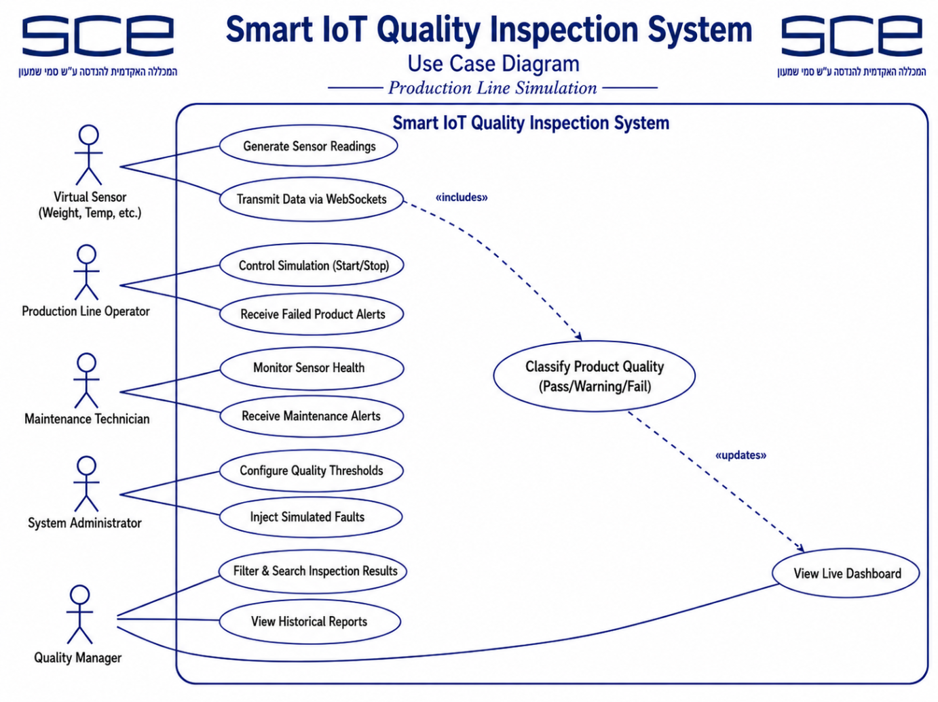
Actors and major use cases for virtual sensors, quality managers, operators, maintenance technicians, administrators, notification flow, and role-based access boundaries.

4.2 Block Diagram
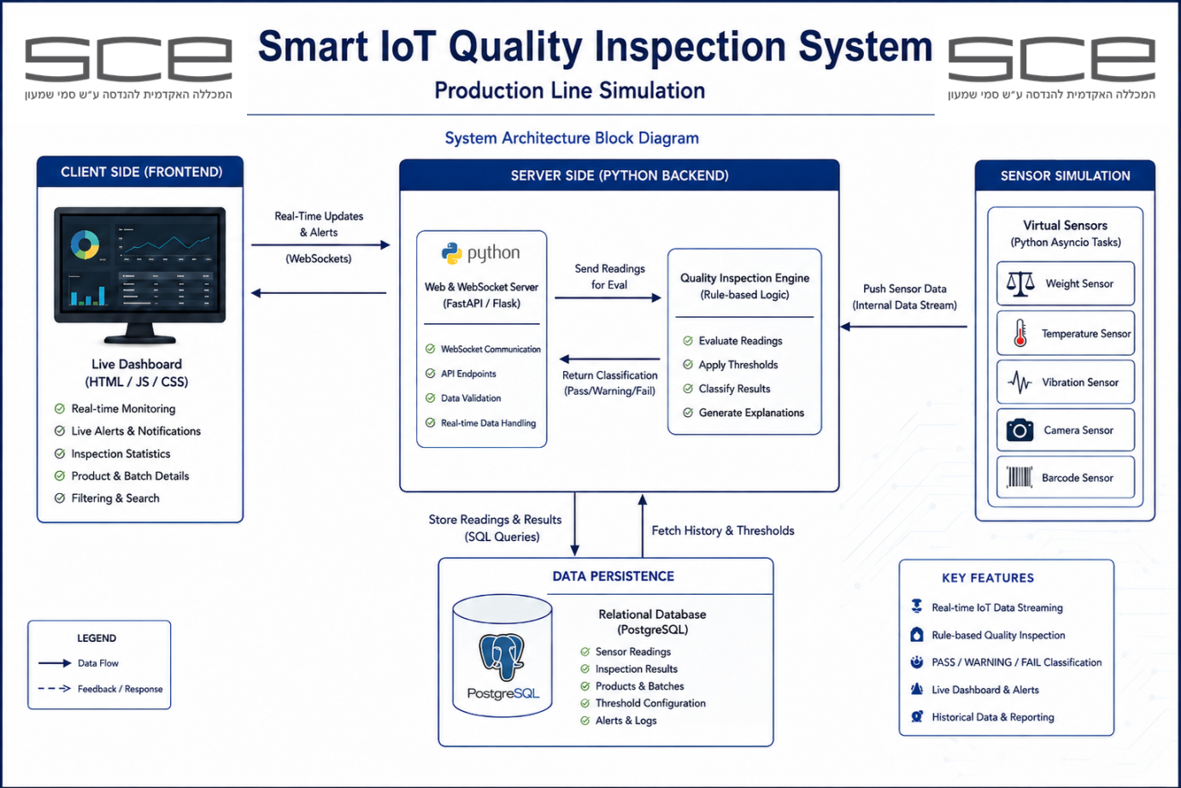
System architecture showing virtual sensor simulators, WebSocket communication, backend server, simulation controller, quality engine, database persistence, dashboard, alerts, and role-aware administration functions.
4.3 Communication Diagram
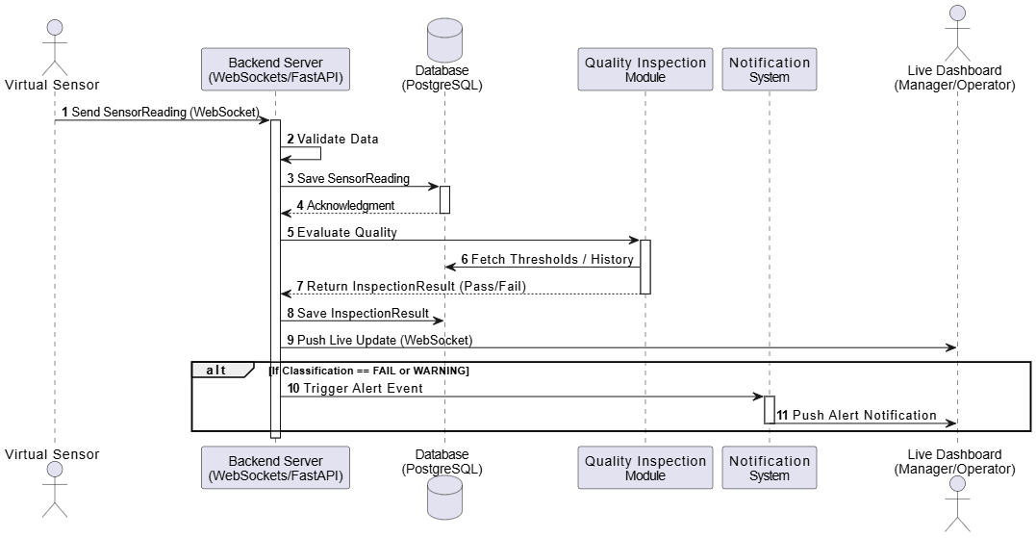
Runtime interaction flow from sensor readings through validation, storage, inspection, alert generation, dashboard updates, acknowledgement history, and notification events.

4.4 Class Diagram
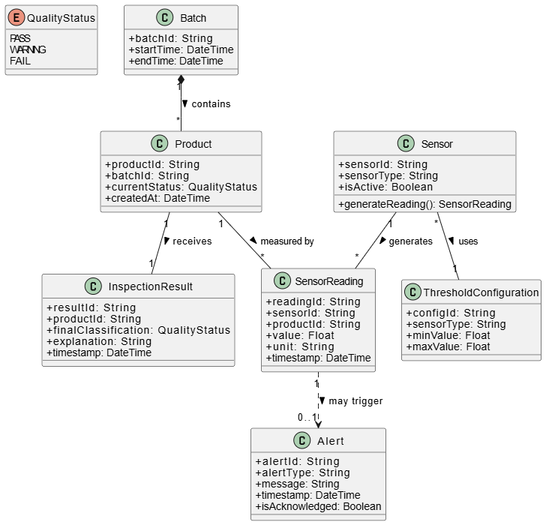
Domain model containing SimulationRun, Batch, Product, Sensor, SensorReading, InspectionResult, ThresholdConfiguration, Alert, User, Role, and QualityStatus relationships.

